**STATEMENT OF ENVIRONMENTAL EFFECTS**

|  |
| --- |
| LOCATION AND PROPERTY DESCRIPTION |

|  |
| --- |
| DEVELOPMENT TYPE: Change of use to a secondary dwelling from a garage/storage room. |
| LGA: Canterbury Bankstown |
| LEP: Canterbury-Bankstown Local Environmental Plan 2023 |

|  |  |  |
| --- | --- | --- |
| Street Number: 8 | Street: Mountview Ave | Suburb: Chester Hill |
| LOT: 47 | DP NO: 29501 | Postcode: 2162 |
| Land use Zone: R2 | Proposed use: Residential | N/A |

**Description of Proposal:**

Change of use from a garage/workshop to a secondary dwelling.

**Description of the site:**

The site is a trapezoid shaped lot with an existing double storey dwelling, and a detached garage/workshop. There is also an in-ground swimming pool at the back – with very slight change in ground contours (approx. 350mm fall over 34m.) The site radius frontage is 12.19m however opens up to over 15m in width at the building line. The total site area by title is 803m2.

Birds Eye View:

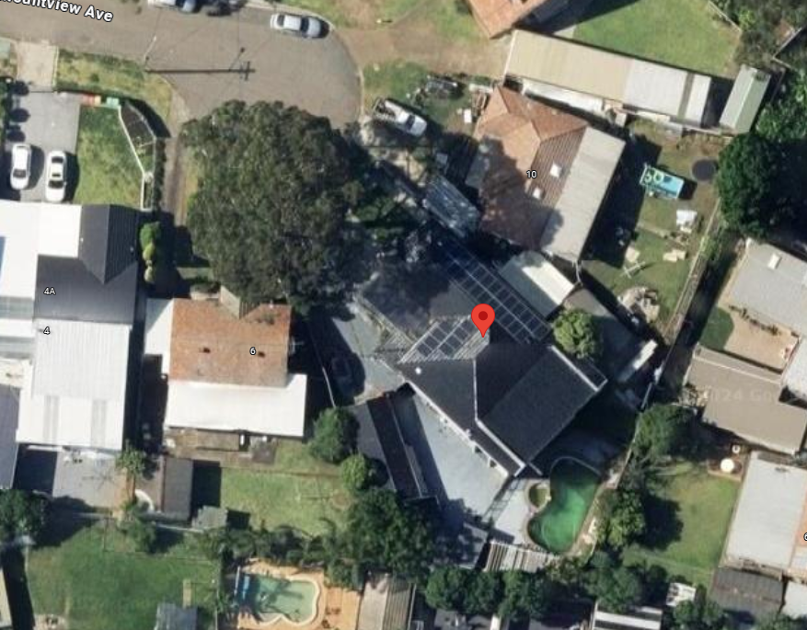

|  |
| --- |
| **CONTEXT AND SETTING** |

|  |
| --- |
| **Will the development:** |

|  |  |
| --- | --- |
| Be visually Prominent in the surrounding area? | No change – internal use change proposed. |
| Be inconsistent with the existing streetscape or Council’s Setback policies? | No. |
| Be out of character with the surrounding area? | No – single storey dwelling proposed. |

**Access, Traffic and Utilities:**

* Legal and practical access is available to the development.
* All services including power, water, electricity, sewer and telecommunication are readily available on site.
* Car Parking – off street car parking available in the form o fa large drive-way and hardstand .

**Environmental Impacts:**

|  |  |
| --- | --- |
| Is the development likely to result in any form of air pollution (smoke, dust, odour etc.)? | During construction the likelihood of air pollution will exist. This will be managed via the erosion and sediment control plans and practice. |
| Does the development have the potential to result in any form of water pollution (eg. Sediment run-off)? | Due to the slope of the land – during construction sediment control fencing will be placed at the rear and southern elevations. |
| Will the development have any noise impacts above background noise levels (eg. Swimming pool pumps)? | No. |
| Does the development involve any significant excavation or filling? | No. |
| Could the development cause erosion or sediment run-off (during the construction period)? | Yes. |
| Is the development considered to be environmentally Sustainable (Including provision of BASIX Certificate where required)? | Yes. |
| Is the development likely to disturb any aboriginal artefacts or relics? | No – not in an environmentally sensitive area. |
| Is the Development within a Heritage Conservation area? | No. |

**Flora and Fauna Impacts:**

|  |  |
| --- | --- |
| Will the development result in the removal of any vegetation from the site? | No. |
| Is the development likely to have any impact on threatened species or native habitat? | No. |

**Bushfire Hazard:**

Nil.

**Stormwater Disposal:**

|  |  |
| --- | --- |
| How will stormwater (from roof and hard standing) be disposed of? | Stormwater discharge via existing stormwater system. |

**Social and Economic Impacts:**

|  |  |
| --- | --- |
| Will the proposal have any economic consequences in the area? | No. |
| Will the proposal affect the amenity of surrounding residences by overshadowing/loss of privacy/increased noise or vibration? | No. |
| Is the development situated in a heritage area or likely to have an impact of any heritage item or item of cultural significance. | No. |

**Flood Impact:**

N/a.

**Canterbury-Bankstown Development Control Plan 2023**

**Former Bankstown DCP:**

|  |
| --- |
| **Section 3- Secondary Dwellings** |

|  |  |  |
| --- | --- | --- |
| **2.7 Building Setbacks** | **Proposed** | **Complies** |
| Lot size 3.1 A secondary dwelling is permissible on a site with a minimum lot size of 450m2 | Lot size 800m2 + | Yes |
| 3.2 Council must not consent to development for the purpose of secondary dwellings unless: (a) the total floor area of the principal dwelling and the secondary dwelling is no more than the maximum floor area allowed for a dwelling house on the land under an environmental planning instrument; and (b) the total floor area of the secondary dwelling is no more than 60m2 or, if a greater floor area is permitted in respect of a secondary dwelling on the land under an environmental planning instrument, that greater floor area. | FSR for proposed secondary dwelling: 45 sqm.  Main dwelling FSR 330 sqm.  Total allowed: 402 sqm. | Yes |
| 3.3 The storey limit for attached secondary dwellings is two storeys. | Single Storey proposed. | Yes. |
| 3.4 The storey limit for detached secondary dwellings is single storey and the maximum wall height is 3m. | Single storey with 2.4m wall height. | Yes |
| 3.5 The siting of secondary dwellings and landscape works must be compatible with the existing slope and contours of the site and any adjoining sites. Council does not allow any development that involves elevated platforms on columns; or excessive or unnecessary terracing, rock excavation, retaining walls or reclamation. | Existing Dwelling – no changes to footprint. | Yes. |
| 3.8 The erection of secondary dwellings is prohibited within 9m of an existing animal boarding or training establishment. | N/A. | Yes. |
| Street setbacks 3.9 The minimum setback for a building wall to the primary street frontage is: (a) 5.5m for the first storey (i.e. the ground floor); and (b) 6.5m for the second storey. 3.10 The minimum setback to the secondary street frontage is: (a) 3m for a building wall; and (b) 5.5m for a garage or carport that is attached to the building wall. | Setback >10m | Yes |
| Side and rear setbacks  **3.11** For the portion of the building wall that has a wall height less than or equal to 7m, the minimum setback to the side and rear boundaries of the site is 0.9m.  3.12 For the portion of the building wall that has a wall height greater than 7m, the minimum setback to the side and rear boundaries of the site is 1.5m. | Setback 900mm side and rear. | Yes. |
| 3.13 Secondary dwellings must not result in the principal dwelling on the site having less  than the required landscaped area and private open space. | POS unimpacted. | Yes. |
| Access to sunlight 3.14 At least one living area must receive a minimum three hours of sunlight between 8.00am and 4.00pm at the mid-winter solstice. Council may allow light wells and skylights to supplement this access to sunlight provided these building elements are not the primary source of sunlight to the living areas. 3.15 At least one living area of a dwelling on an adjoining site must receive a minimum three hours of sunlight between 8.00am and 4.00pm at the mid-winter solstice. Where this requirement cannot be met, the development must not result with additional overshadowing on the affected living areas of the dwelling. 3.16 A minimum 50% of the private open space required for the principal dwelling on the site and a minimum 50% of the private open space of a dwelling on an adjoining site must receive at least three hours of sunlight between 9.00am and 5.00pm at the equinox. Where this requirement cannot be met for a dwelling on an adjoining site, the development must not result with additional overshadowing on the affected private open space. | Plans demonstrate compliance. | Yes. |
| 3.24 The maximum roof pitch for detached secondary dwellings is 25 degrees. An attic or basement is not permitted as part of the dwelling. | Roof pitch 18 and 21 degrees. | Yes. |

**Conclusion:**

This application forms the first part of the BIC lodgement process. The building is an existing structure that has been retrofitted for use as a secondary dwelling. The purpose of the DA lodgement is to establish the usage rights then transitioning to BIC consent for the construction component.